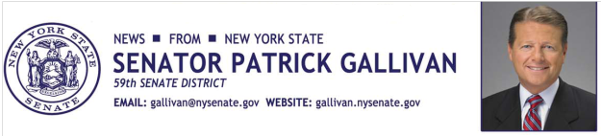
June 8, 2015
For Immediate Release
Contact: Jim Ranney
716-656-8544/716-256-9001

SENATOR GALLIVAN PRESENTS LIBERTY MEDAL TO
BATAVIA RESIDENT

RICKY PALERMO HONORED WITH AWARD BY NY STATE SENATE

Senator Patrick M. Gallivan (R-C-I, Elma) announces that Western New York native Ricky Palermo is the recipient of the New York State Senate Liberty Medal for his contributions to the treatment of spinal cord injuries. The Batavia resident has helped raise more than $1-million for research and awareness. .

“Ricky is a life-long friend and a true inspiration to all New Yorkers,” Gallivan said. “He has dedicated himself to helping others and brings hope to those impacted by spinal cord injuries. I can’t think of a more deserving recipient of the Liberty Medal.”

Palermo grew up in the Byron-Bergen Central School District where he was a star athlete, earning MVP honors in three separate sports. In 1981, he was injured in an automobile accident, which left him paralyzed from the chest down.

Over the past 18 years, Palermo’s annual golf tournament has helped raise funds for research, awareness and treatment of paralysis. He also works closely with The Miami Project in its ongoing effort to treat and ultimately cure paralysis caused by spinal cord injuries.

In 1985, Barth A. Green, M.D. and NFL Hall of Fame linebacker Nick Buoniconti helped found The Miami Project to Cure Paralysis after Nick’s son, Marc, sustained a spinal cord injury during a college football game. Today, The Miami Project is the world’s most comprehensive spinal cord injury (SCI) research center, and a designated Center of Excellence at the University of Miami Miller School of Medicine.

“Ricky is very deserving of this great honor,” said Marc Buoniconti. “He and the entire Palermo family have been such an integral part of The Miami Project team for so many years, and what they have done in order to advance our research is nothing short of remarkable. The contributions of Ricky and the entire Batavia community are directly changing the course of medical history, and are helping to facilitate cures for paralysis that will someday soon hopefully get me, Ricky and the millions worldwide who are living with paralysis out of their wheelchairs,” said Marc Buoniconti.

Palermo is also active with the YMCA of Genesee County.

“There is no one more deserving of the Liberty Medal than Ricky Palermo,” said Greg Watson, Chief Financial Officer GLOW YMCA in Batavia. “Because of Ricky’s passion for helping others, he led the efforts to bring a specialized bike to the Genesee County YMCA allowing individuals with spinal injuries to exercise. It is the only bike of its kind in the area and is a blessing to the many individuals that have benefited from it. Ricky’s positive attitude is an inspiration to everyone he comes into contact with and we are honored that he is part of our YMCA family.”

“I would like to dedicate this Liberty Award to my incredibly supportive family because none of this would be possible without them,” Palermo said. “I also have a close group of friends, like Senator Gallivan, that I would refer to as family.”
The Liberty Medal one of the highest civilian honors that a New York resident can receive and is awarded to individuals who have merited special commendation for exceptional, heroic, or humanitarian acts and achievements on behalf of their fellow New Yorkers

-30-

