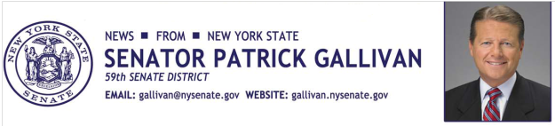
June 16, 2015
For Immediate Release
Contact: Jim Ranney
716-656-8544
716-256-9001

SENATOR GALLIVAN ANNOUNCES SENATE PASSES
BILL TO ALLOW MOOSE HUNTING IN NEW YORK

LEGISLATION WOULD DIRECT DEC TO REGULATE HUNTING SEASON

Senator Patrick M. Gallivan (R-C-I, Elma) announces the Senate has passed a bill (S-93A) that would allow the hunting of moose in New York State. The legislation would amend current environmental conservation law to regulate the taking of moose in the same manner as deer hunting.

“The bill would direct the Department of Environmental Conservation to determine rules and regulations for the hunting of moose, similar to deer and other big game,” Gallivan said. “This will allow the state to better manage the moose population, provide new opportunities for hunters in New York and neighboring states and generate new revenue for the state.”

The legislation authorizes the DEC to establish a licensing process and determine an appropriate hunting season. The department would also set limits and licensing fees.

DEC biologists have estimated New York’s moose population to be about 800, with most of them found in the Adirondack region.

The bill now goes to the Assembly for consideration.

-30-

