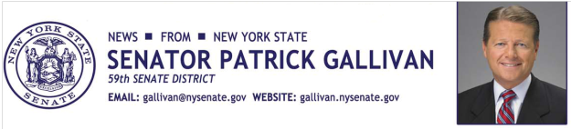
April 22, 2015
For Immediate Release
Contact: Jim Ranney
716-656-8544
716-256-9001

SENATOR GALLIVAN ANNOUNCES FUNDING FOR NYS PARKS

IMPROVEMENTS PLANNED AT LETCHWORTH & KNOX FARM

Senator Patrick M. Gallivan (R-C-I, Elma) announces that Letchworth State Park and Knox Farm State Park will both receive funding for various revitalization and rehabilitation work. The projects are part of a package totaling nearly $72 million for improvements in 60 parks and historic sites across the state.

“New York has some of the best parks in the country and these investments will help protect our natural resources, increase public access and improve the recreational experience for residents and visitors,” Gallivan said.

Letchworth State Park will receive funding for three separate projects, including $1-million in additional funding for the construction of a New Nature Center; $700,000 to upgrade Internet and phone service at the new Nature Center, the park office and other park facilities; and $250,000 to install an automation system at the Castile entrance to the park. The park is known as the “Grand Canyon of the East” and was recently voted Best in the Nation by a USA Today Readers’ Choice survey.

Knox Farm State Park will receive $250,000 to make repairs to various historic structures, including the mansion, the equestrian barn and the greenhouse. The park is the former estate of the Knox Family and covers 633 acres in East Aurora.

The projects are part of the NY Parks 2020 plan, a multi-year commitment to invest both public and private funding in State Parks.

-30-

