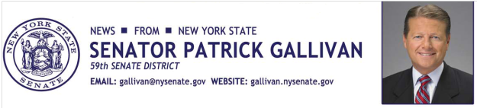
June 9, 2015
For Immediate Release
Contact: Jim Ranney
716.656.8544
716.256.9001

SENATOR GALLIVAN ANNOUNCES SENATE PASSES LEGISLATION TO REFORM NEW YORK’S SAFE ACT

BILL WOULD REPEAL PORTIONS OF CONTROVERSIAL LAW

Senator Patrick M. Gallivan (R-C-I, Elma) announces the Senate has approved legislation (S05837) that would reform the NY SAFE Act by addressing some of the more egregious aspects of the law as it pertains to Second Amendment rights.

The Secure Ammunition and Firearms Enforcement Act was passed in 2013, just one month after the tragic shooting in Newtown, Conn. But instead of focusing on criminals who illegally possessed firearms, the law targets law-abiding gun owners and sportsmen. It also ignores long-established crime prevention techniques and proven public protection strategies for keeping residents and communities safe.

“I voted against the SAFE Act. I believe the law was ill conceived, poorly written, infringes on the constitutional rights of law abiding citizens and does nothing to keep New Yorkers safe,” said Gallivan, a former State Trooper and Sheriff of Erie County. "As we continue efforts to fully repeal the SAFE Act, this bill is a step in the right direction and repeals some of the onerous aspects of the law.

The legislation would:

- Repeal a requirement for establishing an ammunition database.
- Amend the current law to allow for the gifting of certain firearms and ammunition feeding devices to an immediate family member upon the owner’s death.
- Strengthen privacy protections so that a presumption of privacy would be restored to the gun owner, and personal information contained on firearms licenses could not be disclosed.
- Amend the Mental Hygiene Section of the law to require the state notify in writing those people identified as a mental health risk and clarify the appeal process.
- Would replace the New York State Police with the Department of Criminal Justice Services, an administrative, non-law enforcement agency, as the division responsible for the maintenance of the statewide license and record database.

The bill now goes to the State Assembly for consideration.
“The Senate approved this bill with bipartisan support. As there is also bipartisan support in the Assembly, there is no reason whatsoever that this legislation cannot be taken up and passed. It is time for both Republicans and Democrats in the Assembly to deliver and pass these common sense reforms without delay,” Gallivan said

In addition to supporting this legislation, Gallivan has co-sponsored several bills that would further modify the SAFE Act or repeal the law in its entirety.

-30-

