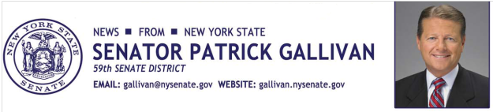
April 24, 2015
For Immediate Release
Contact: Jim Ranney
716-656-8544
716-256-9001

SENATOR GALLIVAN INTRODUCES SRO OFFICER AT
WHEATLAND-CHILI CENTRAL SCHOOL DISTRICT

MONROE COUNTY DEPUTY WORKS WITH STUDENTS, FACULTY & STAFF

Senator Patrick M. Gallivan (R-C-I, Elma) met Friday with Wheatland-Chili Central School Superintendent Deborah Leh, Monroe County Sheriff Patrick O’Flynn and School Resource Officer Laura Michaels, a Monroe County Sheriff’s Deputy. Funding secured by Gallivan in last year’s state budget made it possible for the school district to establish a School Resource Officer (SRO) program in February. In collaboration with the County of Monroe and the Monroe County Sheriff’s Office, the program will continue through the end of the 2014-2015 school year.

State funds are supporting new and existing SRO programs in more than a dozen schools in the 59th Senate district. The program brings local schools and law enforcement agencies together to promote school safety and crime prevention.

“As a former State Trooper and Sheriff of Erie County, I have great respect for law enforcement officers and the positive impact they can have in our schools,” Gallivan said. “In addition to offering security, the officers work closely with school administrators to promote positives relations and conflict resolution.”

“During these fiscally challenging times, we are extremely pleased that the District received $50,000 through the advocacy of Senator Gallivan,” Leh said. “Our students and staff will certainly benefit through this enhanced partnership with the County of Monroe and the Monroe County Sheriff’s Office.”

The role of the SRO is to:
- Improve student perceptions about law enforcement officers by presenting a positive role model of law enforcement, and by building positive working relationships with students, staff and parents
- Establish partnerships with school administrators
- Provide input for emergency/crisis planning, and maintaining a presence in the school
- Help students and staff develop an awareness of personal safety
- Educate students about resources

“I hope to have a positive impact and to continue to make Wheatland-Chili a safe school community,” said Michaels.

Michaels has served as a Deputy since July 2000. She is a Wheatland-Chili parent and District resident.

-30-

