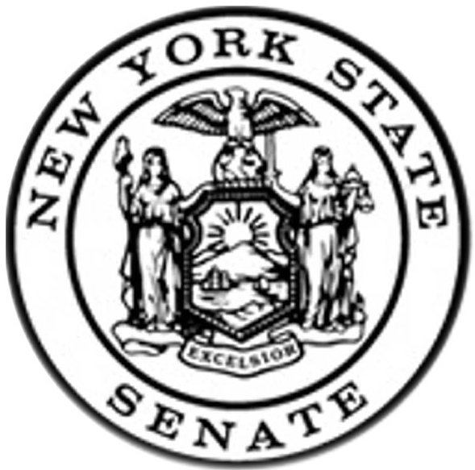

Public Hearing of the New York State Senate Committee on Racing, Gaming & Wagering

September 6, 2011 – 11:00 AM – 2:00 PM

Ontario County Safety Training Facility, Rooms 2 & 3, 2914 County Road 48, Canandaigua, NY 14424

WITNESS LIST

- Robert Porter, President, Seneca Nation of Indians

- Michael D. Kane, President and CEO, Western Regional Off-Track Betting Corporation

- Jeffrey Gural, Chairman, Newmark, Knight, Frank

- Tracy Egan, Executive Director, Thoroughbred Breeding and Development Fund and Jeffrey Cannizzo, Executive Director, New York State Thoroughbred Breeders Association.

- David Brown, President, and Dennis Petrisak, Vice-President, Finger Lakes Horsemen Benevolent & Protective Association

- Nelson Acquilano, LMSW, Executive Director, Council on Alcoholism and Addictions of the Finger Lakes and David Young, Problem Gambling Prevention Coordinator, DePaul’s National Council on Alcoholism and Drug Dependence

