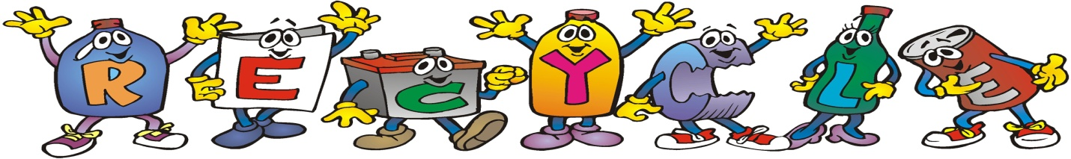

Recycling Day
Sunday, September 30th
10 AM - 3 PM
Rain or Shine!
Sponsored by
Senator Joe Addabbo & Assemblyman Mike Miller

The George Seuffert Sr. Bandshell
Parking lot located in Forest Park; on Forest Park Drive, one block west of Woodhaven BLVD in Woodhaven

ITEMS THAT WILL BE ACCEPTED FOR RECYCLING ARE:
Clothing & Textiles including clothing, coats, bedding, linens, paired shoes, scarves, belts, hats, handbags. ALL ITEMS MUST BE CLEAN & DRY.
Electronics including computers, monitors, cell phones, servers, fax machines, typewriters, TV’s, PDA’s, scanners, copiers, printers, batteries, laptops, cameras, wires, power strips, chargers, cable boxes fans, air conditioners, telephones and VCR tapes. NO APPLIANCES.
Paper including paper fiber and confidential papers. NO CARDBOARD.
Carpeting accepting ‘residential type’ carpeting and foam padding only. NO AREA RUGS.
Household Goods including dishes, glasses, silverware, lamps, pots, and drapes.
Eyeglass Donation

For more information please call Peter DeLucia
in Senator Addabbo’s district office at (718)738-1111

