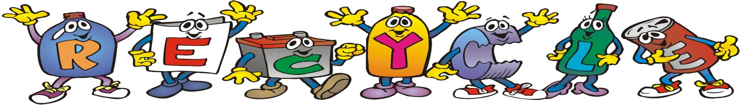

Recycling Day

Sunday, April 15th

10 AM- 3 PM

Rain or Shine!

**Sponsored by**

**Senator Joe Addabbo & Assemblyman Mike Miller**

**The George Seuffert Sr. Bandshell**

**parking lot located in Forest Park**

**on Forest Park Drive, one block west of Woodhaven Blvd in Woodhaven.**

**Items that will be accepted for recycling are**

**Clothing & Textiles** including clothing, coats, bedding, linens, paired shoes, scarves, belts, hats and handbags. ALL ITEMS MUST BE CLEAN & DRY.

**Electronics** including computers, monitors, cell phones, servers, fax machines, typewriters, TV’s, PDA’s, scanners, copiers, printers, batteries, laptops, cameras, wires, power strips, chargers, cable boxes, fans, air conditioners, telephones and VCR tapes. NO APPLIANCES.

**Paper** including paper fiber and confidential papers. NO CARDBOARD.

ALL PAPER ITEMS WILL BE SHREDDED WHILE YOU WATCH TO ENSURE SAFETY.

**Carpeting** accepting ‘residential type’ carpeting and foam padding only.

**Household Goods** including dishes, glasses, silverware, lamps, pots and drapes.

**Book Donation**

**Eyeglass Donation**

**For more information please call Peter DeLucia in**

**Senator Addabbo’s district office at (718) 738-1111.**

