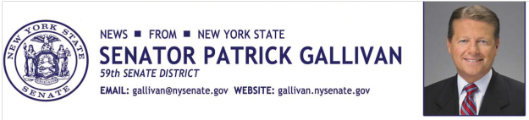

March 12, 2014

For Immediate Release

Contact: AJ Baynes

518.455.3471

SENATOR GALLIVAN VOTES “NO” ON BOARD OF REGENTS INCUMBENTS

Senator Gallivan stands up for our students and against the status quo

On behalf of the frustrated students, parents and teachers I represent, I voted to oppose the confirmation of the four Board of Regents candidates nominated by the state Assembly. Sadly, an opportunity to change course was missed as those responsible for the disastrous implementation of the Common Core were reelected in a flawed process that placed politics ahead of our children.

The flawed roll out of the Common resulted in schools not being adequately prepared as curriculum modules and sufficient resources were not available, professional development opportunities lacking, and deficiencies in the state testing process plentiful.

In an effort to rectify the problems and ensure a high quality education for all, the Senate Education Committee issued a report in December outlining detailed recommendations for improvement. To date, these recommendations have been ignored by those more interested in maintaining the unacceptable status quo.

This stands in the way of our goal of raising our educational standards, improving our schools, and ensuring our students are college and career ready. I will continue, however, to advocate for high educational standards with a sensible approach that fosters the best environment for educators to educate and students to learn.

My vote against the status quo was intended to send a loud message that our children deserve better. Parents are rightfully demanding that this bureaucratic disaster be fixed. I agree. It is time for New York State to focus on providing the best quality education possible so every student can achieve a bright, successful and rewarding future.
###
Photo Credit: New York State Senate

