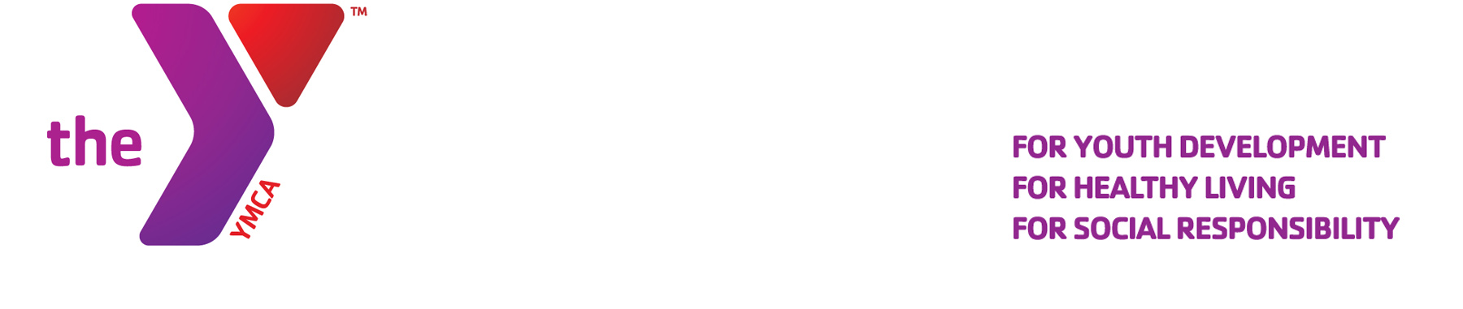
Media Contact:
Helen Gates RYE YMCA
914-967-6363
helengates@ryeymca.org
www.ryeymca.org

For Immediate Release

Sept 30, 2011

International Walk to School Week is taking off across the Sound Shore with help from the Safe Routes to School Committees from Rye, Rye Neck and Mamaroneck. With 9 elementary schools in the area, representing over 4500 children grades K-5, that’s a lot of steps taking to the sidewalks during the week of Oct. 3-7.

With help from the Rye Y and grant funding provided by the United Way of Westchester and NY State Sen. Suzi Oppenheimer, Safe Routes “starter kits” were distributed to 9 local grade schools as a way to encourage safe walking and biking to school. Walking safety tips, banners, walking school bus signs, and an array of incentives were included in the kit for children. Adult messaging such as “Please Put Down the Cellphone” are on lawn signs to appear on school campuses as well as car magnets proclaiming, “Caution. I stop at Crosswalks.”

International Walk to School Week takes place twice a year, in the Fall and Spring. Safe Routes to School is an international program recognized by the CDC as an effective initiative in helping to create healthier communities.

Photo caption:

Parent representatives pick up their Safe Routes to School Starter Kits at the Rye Y.

Left to Right: Lucy Cassidy of Osborn School, Gregg Howells, Rye Y Executive Director, Marla Schneider - Rye Neck SRTS Chair, and Lisa Urban from Milton School. Missing from photo: Kim Larsen, Mamaroneck SRTS Chair.

