October 30, 2009
Governor David Paterson
New York State Capitol
Albany, NY 12224

Dear Governor Paterson:

We are writing to ask you to withdraw your proposal to make a $686 million in mid-year school aid cuts. Cuts to state school aid undermine the quality of education in all schools-those that are already under-funded and those that currently have the resources to meet every child’s needs. Moreover, cuts in school aid also create a greater burden on local taxpayers. There is an undeniable correlation between rising property taxes and the failure of the state to provide adequate school aid.

The New York State Court of Appeals found in the Campaign for Fiscal Equity (CFE) case that far too many New York’s school children are in schools that are under-funded and under-resourced, and that these children are being denied their constitutional right to a “sound, based education.” The problem of the underfunding of the schools and the students most in need is not restricted to one community. It exists in every part of the state from New York City to Buffalo to Brentwood and Elmira. It plays rural communities, small cities, suburbs, and the Big 5 cities.

There are reasonable and effective alternatives to find cost savings and address the deficient that should take precedence over any mid-year cuts in school aid. Among those options are:

- Utilization of the $1.5 billion in the state’s rainy day reserves to close out the current fiscal year in balance.
- Elimination of the Empire Zone program which would save the state approximately $600 million; this program has been ineffective and fraught with abuse.
- Bulk purchasing of the prescription drugs as authorized in this past year’s state budget would save hundreds of millions of dollars and is awaiting implementation.
- Collection of hundreds of millions of dollars in taxes that are due from non-Native Americans on tobacco products sold at Native Americans retail outlets. Native Americans should be provided coupons to ensure their unfettered to purchase these tobacco products tax free, but the state should be collecting taxes due from other purchases.

Governor David Paterson
Page 2

- Refinancing outstanding state debt on which savings can be realized because of the current low interest rates-refinancing of tobacco settlement bonds alone could save $500 million.

Clearly, there are alternatives to cutting funding for schools. Earlier this year, the State froze the statewide implementation of funding increases due under the statewide 2007 settlement of the CFE litigation and, therefore, froze the opportunities available to our neediest schools and students. Those increases committed for 2007 were designed to make up for years of chronic underfunding, and to simply create adequacy in the provision of resources for learning. The $686 million in mid-year school cuts would be asking schoolchildren and local taxpayers to compound this sacrifice of educational opportunity, which will have long-term economic consequences for our state. Quality education is essential to fueling the economic recovery.

For the reasons we have stated above, we will oppose any cuts in state aid to our school districts and will promote reasonable and responsible alternatives such as the ones proposed in this letter.

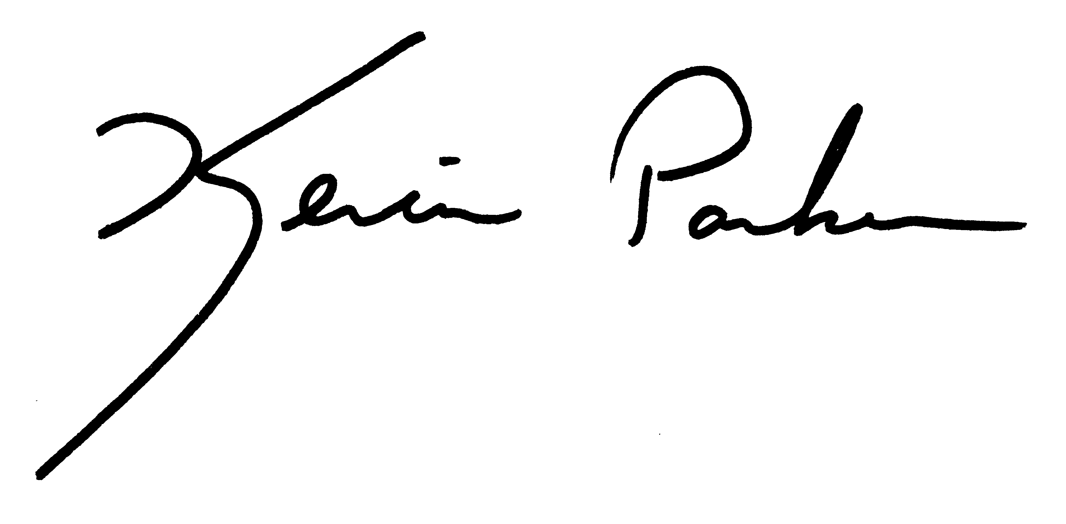
Yours in Partnership,

Kevin Parker

