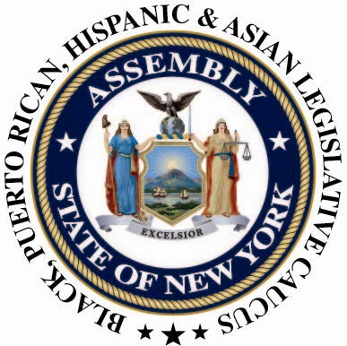

CONTACT:
Nantasha Williams
(518) 455-5327
bphacaucuspress@gmail.com
For Immediate Release: August 12, 2013

The NYS Black, Puerto Rican, Hispanic, and Asian Legislative Caucus Applaud Stop and Frisk Ruling
Reforming Stop and Frisk has been a top priority

Albany, NY- Reforming "Stop and Frisk" has been one of the top priorities of the NYS Black, Puerto Rican, Hispanic, and Asian Legislative Caucus for at least the past decade. We strongly support and applaud Judge Shira A. Scheindlin’s decision on the New York Police Department’s Stop and Frisk Program. In 2012, the Caucus traveled to D.C. to lobby the Department of Justice to investigate NYC’s Stop and Frisk practices. While in D.C. the Caucus also briefed the Congressional Black Caucus on the status and implications of this controversial program.
The Stop-and-Frisk program demonstrates not only a disregard for the Fourth Amendment, (which protects against unreasonable searches and seizures) but it also fosters unfair treatment and illegal searches in Black and Latino communities citywide. The existence of Stop-and-Frisk creates a bias, and as Judge Shira A. Scheindlin said, "the city adopted a policy of indirect racial profiling by targeting racially defined groups for stops based on local crime suspect data” . The Caucus will continue to fight for equitable legislation that allows for all citizens to be treated equally and not discriminated against based on their race and ethnicity.

###

