Tax Lien Assistance Outreach Event

Sponsored by
NYS Senator Joe Addabbo,
NYS Assembly Member Mike Miller
and NYC Council Member Elizabeth Crowley

Representatives from NYC Department of Finance (DOF),
the Department of Environmental Protection (DEP)
and the Department of Housing Preservation (HPD)
and Development will be on hand to meet individually to discuss eligibility for billing programs, water debt assistance and setting up payment plans.
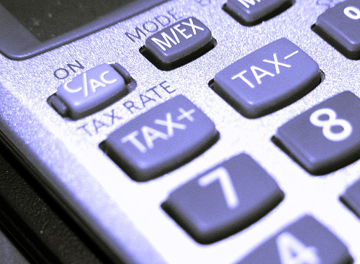
Date - Wednesday, July 6, 2011
Time – 4:00 PM to 7:00 PM
Location – PS 91 68-10 Central Avenue
Glendale (Use entrance on 68th Place)

This is a FREE event.

Please call Peter DeLucia at 718-738-1111 to RSVP.

