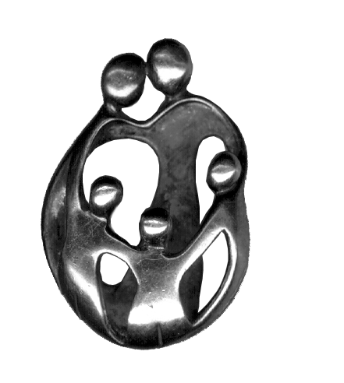UPC

SOUTHERN TIER COMMUNITY HEALTH CENTER NETWORK

500 Main Street 132 West Main Street 9864 Luckey Drive
Olean, N.Y. 14760 Cuba, N.Y. 14727 Houghton, N.Y. 14744

August 19th, 2013

Contact: Gail C. Speedy, Executive Director
Universal Primary Care
(716)701-6831

FOR IMMEDIATE RELEASE

OLEAN, N.Y. – Universal Primary Care, a Federally Qualified Health Center, cut the ribbon Thursday, August 15, 2013, on a larger Olean office to meet its expanding demand for patient care services. Assisting with the event was The Honorable Catharine M. Young, NYS Senate, 57th District.

“Due to the hard work and dedication of staff, partner organizations, local officials, and volunteers, Universal Primary Care is thriving and expanding. With this new site, the proactive, comprehensive health care services offered by UPC will become available to more of those in need, providing a tremendous service to our community,” said Senator Young.

The new site, located next to the Social Security Office in Blue Bird Square, is a 10,000 square foot facility, which allowed the safety net clinic to add additional exam rooms, a behavioral health and care management office area and a large, community multi-purpose room.

“This expansion represents two years of hard work to prepare us for this day,” said Michael DeRose, Chairman of the Board of Directors. He noted that the clinic committed to hiring two physicians and a behavioral health therapist while also adding other services and programming to build up the clinic’s demand to help make the move sustainable. From that point, the hunt was on to find a space large enough to meet the clinic’s needs.

“It’s important for us to be centrally located and within walking distance not only to the clinic but to other services a patient may need. We are especially grateful to Park Centre Development for building out this space to meet our requirements.”

The new clinic now holds 19 exam rooms, two treatment rooms, an ultrasound room and a non-stress testing area for obstetrical patients. Additionally, the clinic operations have been laid out to be more comfortable for patients, meet the demands of modern medicine and also enhance privacy.

A corresponding administration area was designed to house the care management team, behavioral health therapist and administrative offices as well as the clinic’s residency offices and a large multi-purpose room.

“We are extremely proud of what we have been able to accomplish,” said Executive Director, Gail Speedy. “We are also so excited to share this with the community.”

While the clinic officially opens for business for all Olean office visits on May 6, 2013, the clinic cut the ribbon as part of its National Health Center Week celebrations.

“We want to emphasize to all of our patients that we are still here for them and can be reached at any time through calling the office,” said AnnMarie Zimmermann, M.D.

UPC has earned the highly competitive designation of a Federally Qualified Health Center. In doing so, it provides primary care, obstetrics, gynecology, behavioral health, care management, well/sick child and geriatric care to all who seek its services, regardless of ability to pay. The clinic is nationally recognized for its patient-centered medical home by the National Center for Quality Assurance and is a model practice for the Centers for Medicare/Medicaid/FQHC Advanced Primary Care Practice demonstration project. UPC is also proud to serve as the outpatient family medicine teaching site of the Olean General Hospital/University of Buffalo School of Medicine Family Medicine Program. UPC was established in 2004 under a volunteer Board of Directors.

- 30 -

