BLOOD DRIVE
Sponsored by West Babylon Little League

Date: Thursday, June 7, 2012
Time: 3:00pm ~ 9:00 pm
W. Babylon Community Youth Center- 71 Sawyer Ave.

ALL DONORS WILL RECEIVE A PAIR OF METS TICKETS
(Tickets to be sent in the mail)
LETS GO METS!

Your donation will help to save up to THREE lives.
Our community hospitals need your help.
Please share this lifesaving gift!
Thank you for caring!
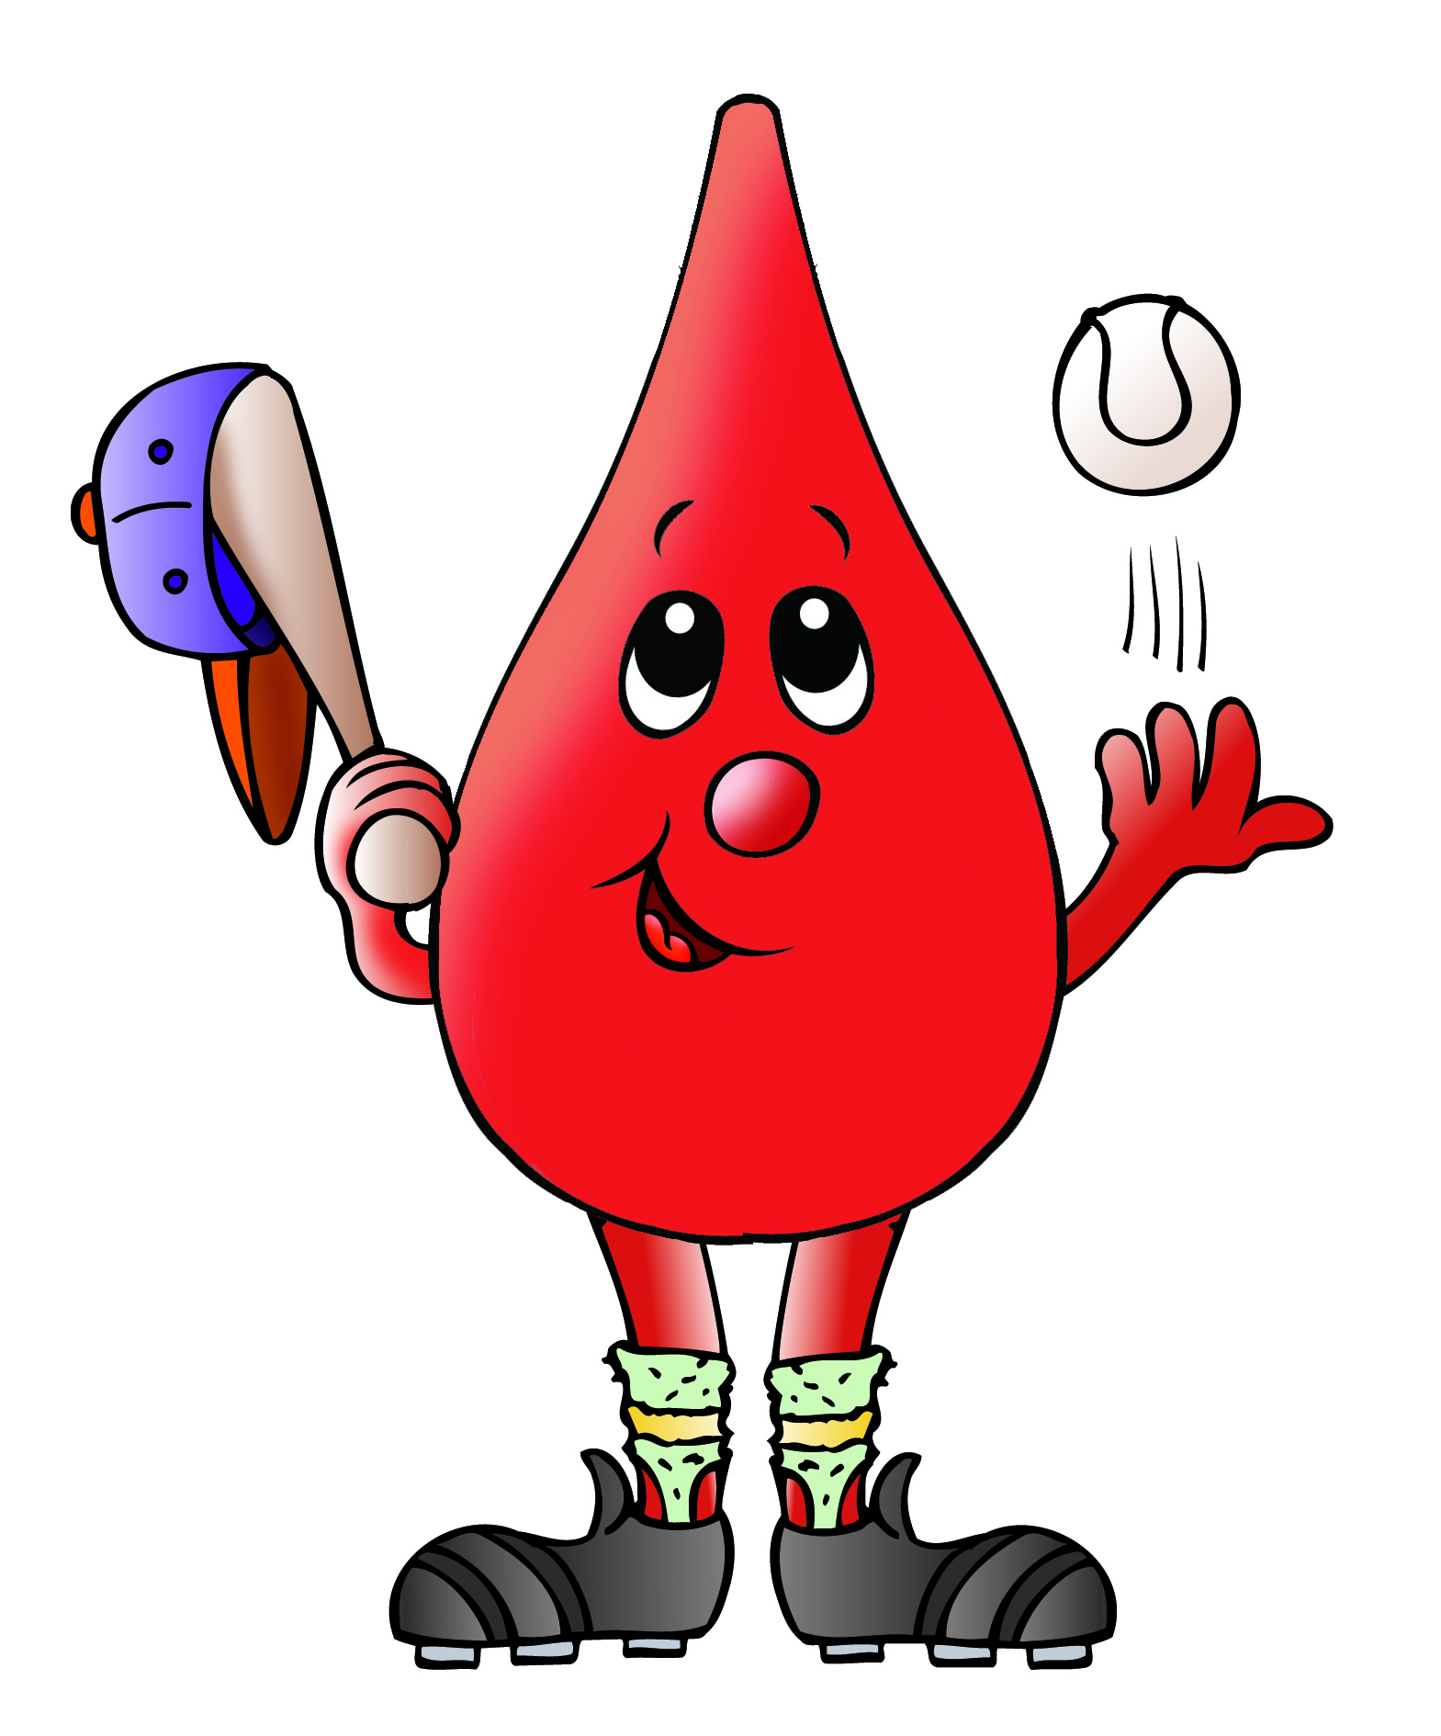

Eligibility Criteria:
- Bring ID with signature or photo.
- Minimum weight 110 lbs.
- Age 16 – 75 (16 year olds must have parental permission.
- Age 76 and over need doctor’s note)
- Eat well (low fat) & drink fluids
- No tattoos for past 12 months
For questions concerning medical eligibility call 1-800-688-0900.

To make an appointment, please contact
Doreen Fiscina @ dfiscina@nybloodcenter.org
Or 516-478-5031.


Walk-ins are always welcome...

