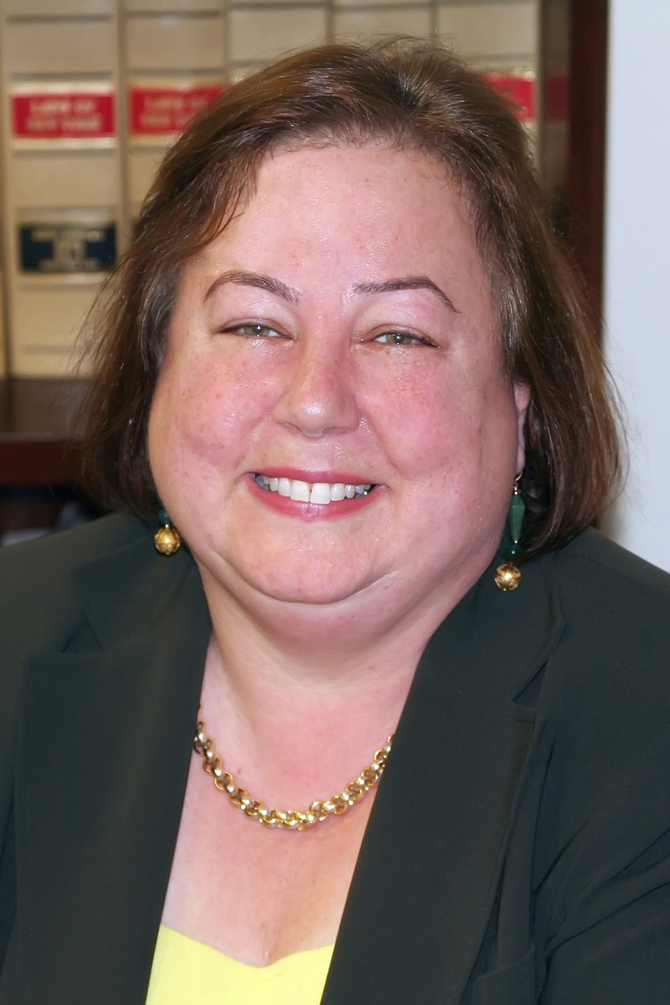
Making 3-1-1 Work…
for YOU:
Tips from Senator Liz Krueger

“311” is a free service available via phone (3-1-1) and the internet (www.nyc.gov/apps/311/) that offers access to government services. Through 3-1-1 you can obtain information, report a problem and request services. To best utilize these services and ensure your requests and/or concerns are addressed, Senator Krueger suggests the following steps:

Before You Call 3-1-1:
- Compile a list of details supporting your claim. Your report should be as specific as possible and should include: dates, times, locations and names (if possible). For example, if you believe your building is running an “illegal hotel,” then you should have the address, apartment number(s) in question and the dates/times you have seen people coming in/out.
- Know what you’re going to say before you call. Before you call, make an outline of what you want to say. This will help ensure you do not leave out any details or stray off message. A clear, concise complaint has the greatest chance of being addressed quickly.
- Use a “buzz word” to describe your problem. For example, if apartments are being rented out for 30 days or less, it is considered an “illegal hotel.” Or, if you are concerned about your building’s improper trash disposal then refer to it as a trash problem and/or a rodent problem.

While on the phone with 3-1-1, get certain information:
- The Service Request Number for the report you’ve just made. Each report is given a Service Request Number which will allow you to track the status of the report in the future.
- The agency your report is being sent to. It will make it much easier to follow up with your claim if you know which agency is working on it.
- The name of the 3-1-1 representative you speak to and the date/time you called.

After you have filed your report:
- Check the status of your report by using your Service Request Number. You can do this over the phone or via the website.

- If your claim is not being addressed, contact Senator Krueger’s office for further assistance. If you have not received any status updates within a reasonable timeframe, we can follow up on your claim. However, in order to do so we will need your Service Request Number. To contact a member of Senator Krueger’s staff, please call: (212) 490-9535.

