|  |  |  |
| --- | --- | --- |
| SEAL | Congressional Seal - Dear Colleague letterhead | **cityseal** |
|  |  |  |
| State Senator Liz Krueger  Assembly Member Micah Kellner  Assembly Member Robert Rodriguez  Assembly Member Dan Quart | Congresswoman Carolyn B. Maloney | Borough President Gale Brewer  Council Member Daniel R. Garodnick  Council Member Benjamin Kallos |

May 9th, 2014

Mr. Joseph Martens

Commissioner

New York State Department of Environmental Conservation  
625 Broadway  
Albany, New York 12233-0001

Dear Commissioner Martens:

We are writing yet again regarding the permit(s) renewal application submitted by the Dept. of Sanitation New York (DSNY) for the construction and operation of the 91st St. Marine Transfer Station (MTS). We understand that the renewal applications were submitted to DEC on April 11th and a determination can be made anytime up until mid-October, when the previous permits expire.

We urge DEC to pause and re-evaluate the situation before renewing these permits. Conditions at the location and surrounding area have changed significantly, since the original permits were issued, and a public hearing and full reevaluation would be the most responsible course of action under these altered environmental circumstances.

We have previously highlighted many ways in which conditions have changed with regards to the MTS and surrounding area. Please review the following concerns which we feel *must* be addressed prior to moving forward with the permit renewal review process:

∙ Superstorm Sandy has fundamentally changed the way we must approach construction along our waterfront. During Superstorm Sandy, the area surrounding this site was flooded as much as four blocks inland from the East River. Following Sandy, FEMA issued new flood maps indicating apparent danger to the MTS location and situation. According to the new FEMA flood maps, the 91st St. MTS platform will sit 5.59 feet BELOW the estimated 100 year floodplain, effectively placing the structure in danger and exposing the surrounding community and river to refuse from the site. It is worth noting that *structurally*, nothing has been changed in the MTS plans to protect against such a scenario. Yet, the City has gone so far as to attempt to waterproof portions of the first level, revealing that they are aware and worried about a flood condition, but refuse to raise the structure above the FEMA flood zone. Our collective fear is that this will result in catastrophic damage when the structure is flooded with several feet of fast moving water, for which the East River is infamous. Would this design have been granted the necessary permits by DEC if it already sat nearly six feet below the previous floodplain when the original permits were granted?Is there an example of similar circumstances in which DEC has granted such approval?

∙ The surrounding area has seen a sharp upturn in population growth in addition to a significant number of construction projects currently underway. This project will further exacerbate the various problems associated with construction such as street level activity, congestion and air pollution.

**∙** The immediate ten block radius surrounding the site is home to five new schools that have opened since the original permit was approved.

**∙** First and Second Avenues have seen the implementation of Select Bus Service, which occupy an entire lane, and First Avenue is now also home to a protected bike lane. These changes in the streetscape have altered traffic patterns in the area in the time since the original EIS was conducted.

∙ The air quality on the Upper East Side and Southern Harlem is among the worst in the City. The continued use of #6 heating oil and traffic congestion contribute to these already unacceptable conditions. Adding hundreds of diesel burning garbage trucks per day and waste to a geographic area already over burdened with contaminants will aggravate the poor air quality already burdening this community.

You have previously indicated (in your letter of March 26th) that “As set forth in the State Environmental Quality Act (SEQRA) regulations, permit renewals where there will be no material change in permit conditions or the scope of permitted activities, are Type II actions. Type II actions have been determined not to have a significant impact on the environment or are otherwise precluded from environmental review under article of the Environmental Conservation Law.” It is clear to the interested parties (including the applicant by virtue of their first level redesign) that the environmental conditions have changed drastically, and therefore must again be reviewed in accordance with SEQRA regulations.

In addition to our concerns, the community has gathered over 4,000 letters requesting a reevaluation of the project as well as public hearings, citing many of the concerns we have identified. Please find these letters enclosed for your review.

Should you have any questions regarding our concerns or request, please do not hesitate to follow up with Patrick Madigan in Senator Krueger’s office (212) 490-9535 or [patrickmadigan1@gmail.com](mailto:patrickmadigan1@gmail.com). Thank you in advance for your time an attention to this matter.

Sincerely,

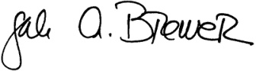

Gale Brewer

Manhattan Borough President

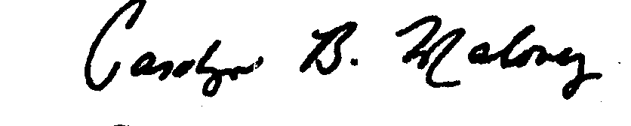

Carolyn Maloney

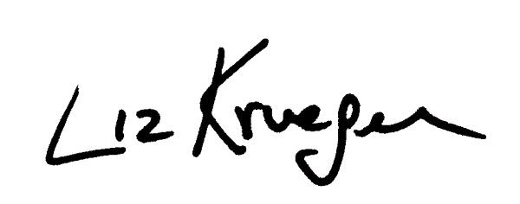Congresswoman

Liz Krueger

State Senator

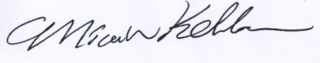

Micah Kellner

Assembly Member

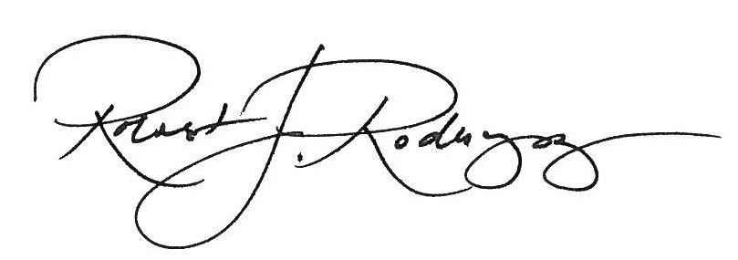

Robert Rodriguez

Assembly Member

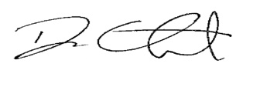

Dan Quart

Assembly Member



Daniel Garodnick

Council Member

Signature_Ben_Kallos_Blue_Straight

Benjamin Kallos

Council Member

P.S.

Please also find enclosed a Pledge 2 Protect presentation, which contains many helpful graphics and statistics to accompany the concerns we’ve laid out regarding flooding, air quality, etc.

Cc:

John F. Cryan

Regional Permit Administrator

Division of Environmental Permits

47-40 21St St.

Long Island City, NY 11101