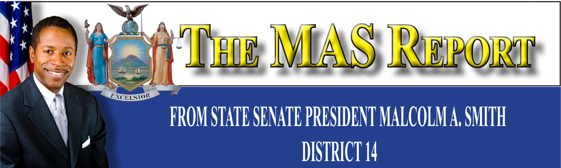

**Employment Opportunities**

* The filing period for the NYC Probation Officer Exam will be held from June 2, 2010 through June 22, 2010. To print out your application go to nyc.gov/dcas.
* Congressman Gregory Meeks is holding a John F. Kennedy Airport Job Fair. Representatives from the Port Authority of NY & NJ, Airline Companies, Major Airport Service Companies and Cargo Business will all be present. For more information or to pre-register call the Congressman’s office at (718) 725-6000.
* The Conerence of Minority Transportation Officials (COMTO), New York Chapter and Smalls Electrical Construction, Inc. are Community and Industry Partners seeking New School Development Team Leader for district school scheduled to open in the Fall, 2011. Applicants are required to send their resumes and letters to [jsmalls@smallselectrical.com](mailto:jsmalls@smallselectrical.com) as soon as possible. Interviews will be held until 6/30/10. Call Jeffrey Smalls for more information at 917-709-9721.

**Upcoming Events**

* ***Health Walk & Fitness Day.*** Saturday, June 19, 2010, Springfield Park, 147th Avenue & 184th Street, Springfield Gardens. Walk begins at 11:30 a.m. and the workout, led by Body by Denise, begins at 12 Noon.
* **Youth Business Network.**  Begins July 6th. Forty students have been chosen to participate in this year’s program. The students will be placed in businesses in Far Rockaway and Queens
* ***Jump and Ball VI.*** July 31, 2010 – August 29,2010, Saturdays & Sundays 10 AM – 6 PM. Pre-registration: July 24th Roy Wilkins Park & Recreation Center. 177th Street & Baisley Boulevard, Jamaica, NY.

Dear Friend,

The warm weather is upon us and with it comes many exciting activities.

First, it’s important that I remind you that we are in the final stages of conducting the 2010 Census. The Census determines the amount of funds and resources that our community needs depending on our population as a city and state. The Census also determines how many representatives you will have fighting for you in City Hall, Albany and Washington D. C. If a verified, ID-carrying Census workers knock on your door, please cooperate with them. It’s imperative that our community be counted.

I would like to thank everyone that came out to my youth town hall meetings. Both, the one in Southeast Queens and Far Rockaway were a tremendous success. A panel of experts and were on hand to discuss financial literacy.

I would first like to announce that my summer youth employment program, the Youth Business Network, kicks off July 6th. Thirty-five students have been selected and will be placed in businesses throughout the borough. Shortly after on July 31st, the basketball and double-dutch tournament Jump and Ball VI will begin at Roy Wilkins Park. Athletes from around the borough will compete for the championship trophy.

In September I am also hosting a luncheon for seniors during Senior Appreciation Week and my annual Family Day in the Rockaways.

As always, my staff and I are here to assist you with important matters. Please do not hesitate to call my district office at (718) 528-4290 if you have any questions or concerns and for specifics on these upcoming events.

All my best



Malcolm A. Smith