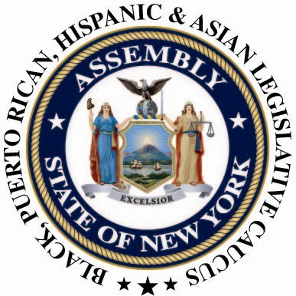

PRESS CONTACT: Nantasha Williams
Office: (518) 455-5327
bphacaucuspress@gmail.com
For Immediate Release: May 22 2013

Civil Rights: Post Obama Conversation
The Black, Puerto Rican, Hispanic, and Asian Legislative Caucus Host a Forum on Civil Rights
ALBANY,NY -- On the heels of the New York State Assembly's passage of the DREAM Act and as America moves into the second term of President Barack H. Obama the New York State Black, Puerto Rican, Hispanic, and Asian Legislative Caucus presented a thought-provoking conversation about the past successes and future struggles of the civil rights movement. The event took place Monday, May 22, 2013 at the Legislative Office Building in Albany, New York.
Jennifer Jones Austin, CEO & Executive Director of Federation of Protestant Welfare Agencies; Dr. Alice Green, Executive Director of The Center for Law and Justice; Guillermo Chacon, President of the Latino Commission on AIDS and Alphonso David, who serves as Deputy Secretary of Civil Rights for Governor Andrew Cuomo, kicked off the discussion facilitated by Dr. John Flateau, Co-founder of the DuBois Bunche Center for Public Policy at Medgar Evers College (CUNY). The audience of invited community leaders, students, elected officials, advocates, and the general public participated in a dialogue that was said to assist the Caucus in a plan of action for the future.
“There is still a civil rights crisis among the Black and Latino communities. For both the unemployment rate is almost double the national average; gun violence is the leading cause of death among young males and the high school graduation rate is about 50%,” said Assemblyman Karim Camara, Chairman of the Black, Puerto Rican, Hispanic, and Asian Legislative Caucus. The time has come for us to come together and initiate a strategy for change among the poorest of our New Yorkers. Minorities still face a severe disadvantage in this country and we must continue the fight to give everyone a chance at the American Dream.”
"Civil rights are of paramount importance to all people, and what unites everyone in the United States. Included in these rights is to promote and ensure that all people, regardless of age, race or ethnicity have equal access and opportunity to participate in health care and human service programs without discrimination." -Assemblyman Felix W. Ortiz, Chairman of the New York State Puerto Rican/Hispanic Task Force
"The civil rights movement was and is about more than human rights. It is about true economic equity that ensures equal opportunity and access to healthcare, education, and income leading to the achievement of the American Dream for all." - Jennifer Jones Austin, CEO of Federation of Protestant Welfare Agencies
"We believe that that minority and low-income New Yorkers are at a critical junction today," said Nicole Jordan, Executive Director of the Black, Puerto Rican, Hispanic, and Asian Legislative Caucus. "In order for Black and Latino communities to reach their full potential, we need to create comprehensive and inclusive legislation that bring us together. This forum allows us to bring together the brightest minds equip with the knowledge and passion to build on our successes, but also to learn from our struggles.
The forum grew out of the Black, Puerto Rican, Hispanic and Asian Legislative Caucus commitment to achieve cultural diversity, as well as social and legislative change. The Caucus will continue to partner with a number of organizations to promote diversity, understanding and inclusiveness of minorities in New York State government and the nation. The Caucus continues to tackle minority issues through its annual “People’s Budget”, an analysis of the Governor’s Executive Budget and its effects on poor, low-income, and middle class New Yorkers and communities of color.
This event was said to be the first in a series to address the core issues civil rights issues and policies affecting communities of color. The next event is schedule for fall of 2013 in New York City and is said to focus completely on education, with forums addressing immigration, health, economics, gun control and the justice system to follow.

###

