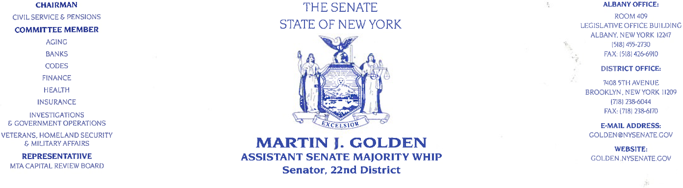

December 13, 2012

MTA Chairman and CEO Joseph Lhota
347 Madison Avenue
New York, New York 10017

Dear Chairman Lhota,

We are compelled to write today in response to the announcement that the Metropolitan Transit
Authority is set to vote next week on a proposal to significantly raise the toll on the Verrazano
Narrows Bridge. As elected officials who represent many hard-working folks who travel this
Bridge each and every day, we ask that the MTA Board reject such proposal.

This proposal will hit the pockets of all New Yorkers who traverse the Verrazano Bridge for the
purposes of work, shopping, medical care, family visits, and more. It is just unacceptable that
the most expensive bridge in the world, already at $13, has the potential to become more
expensive. To ask those who pay cash to spend an additional $2, and those with E-Z Pass to pay
an additional $1.06, is simply outrageous.

In these difficult economic times, the last thing New Yorkers need is the burden of additional
travel expenses. The proposal now before the MTA will further strain the budgets of millions of
New York’s families and cause a loss of revenue for countless businesses. This proposal is not
only misguided, it is something New Yorkers are not willing to accept.

We hear this in our community, along our commercial avenues, and in our homes. That is why
we ask you to vote against this plan for the Verrazano Bridge, and engage us in a dialogue so to
create a program that will offer a multiple trip discount plan similar to that of the Port Authority.

No time has been better than now for the MTA to show New Yorkers that it does in fact account
for the personal financial responsibility of their customers when making such decisions. On
behalf of every single motorist who utilizes the Verrazano-Narrows Bridge, we ask the MTA
Board to oppose this plan. We look forward to working with you to create a more fiscally
responsible approach that will be more acceptable to our constituents.

Sincerely,
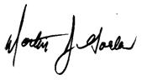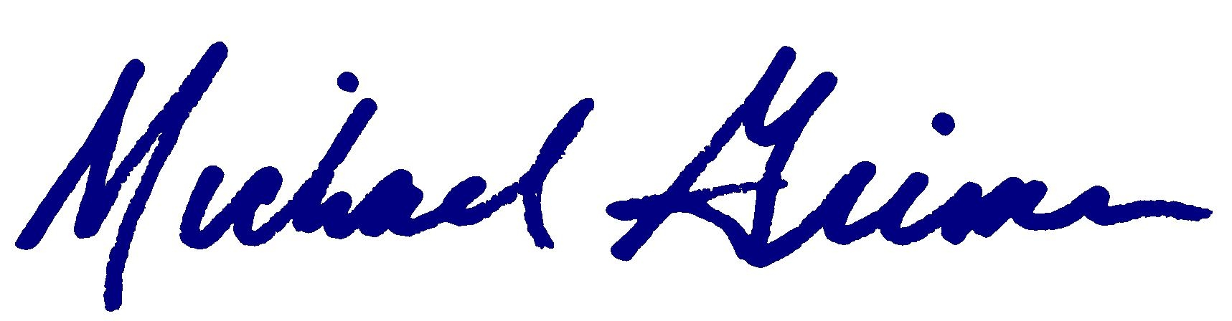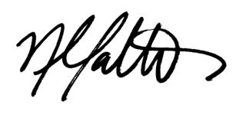
Martin J. Golden Michael G. Grimm Nicole Malliotakis
Member of the Senate Member of Congress Member of Assembly

