What I'm Thankful For
I'm thankful for being a kind and artistic person.
I am a kind person. Sometimes I hold doors for people wherever I go. Another thing is I've helped out with sixth grade donations for different organizations. Sometimes I help my teachers too and even my peers. For example, my sixth grade teacher lost her son to cancer, so she does a fundraiser every year. I helped her with the Super Cooper fundraiser to raise money for kids with cancer. Also, I do these things to help out my family. I helped my mom clean and make her laugh.I do this to make people happy. This is one way I try to make people happy with my talents. For example, when my mom is sad or sick I might draw something for her. I also try to be kind & ask if she needs anything from me. I love helping out. This is how I become my best self.
I am a very artistic person. When I am free I draw some stuff. I can draw just about anything. I have a hard time drawing really hard stuff, but I’m working on it. When I draw it helps me calm down. It gets me thinking of stuff. For example, I made this picture last year along with other pictures that I drew ever since I got autism. It makes me think before drawing. It makes me unique in my own way since I draw. It’s also a way to calm me down. Sometimes I draw random stuff.
In conclusion,I am thankful for being kind and an artistic person.
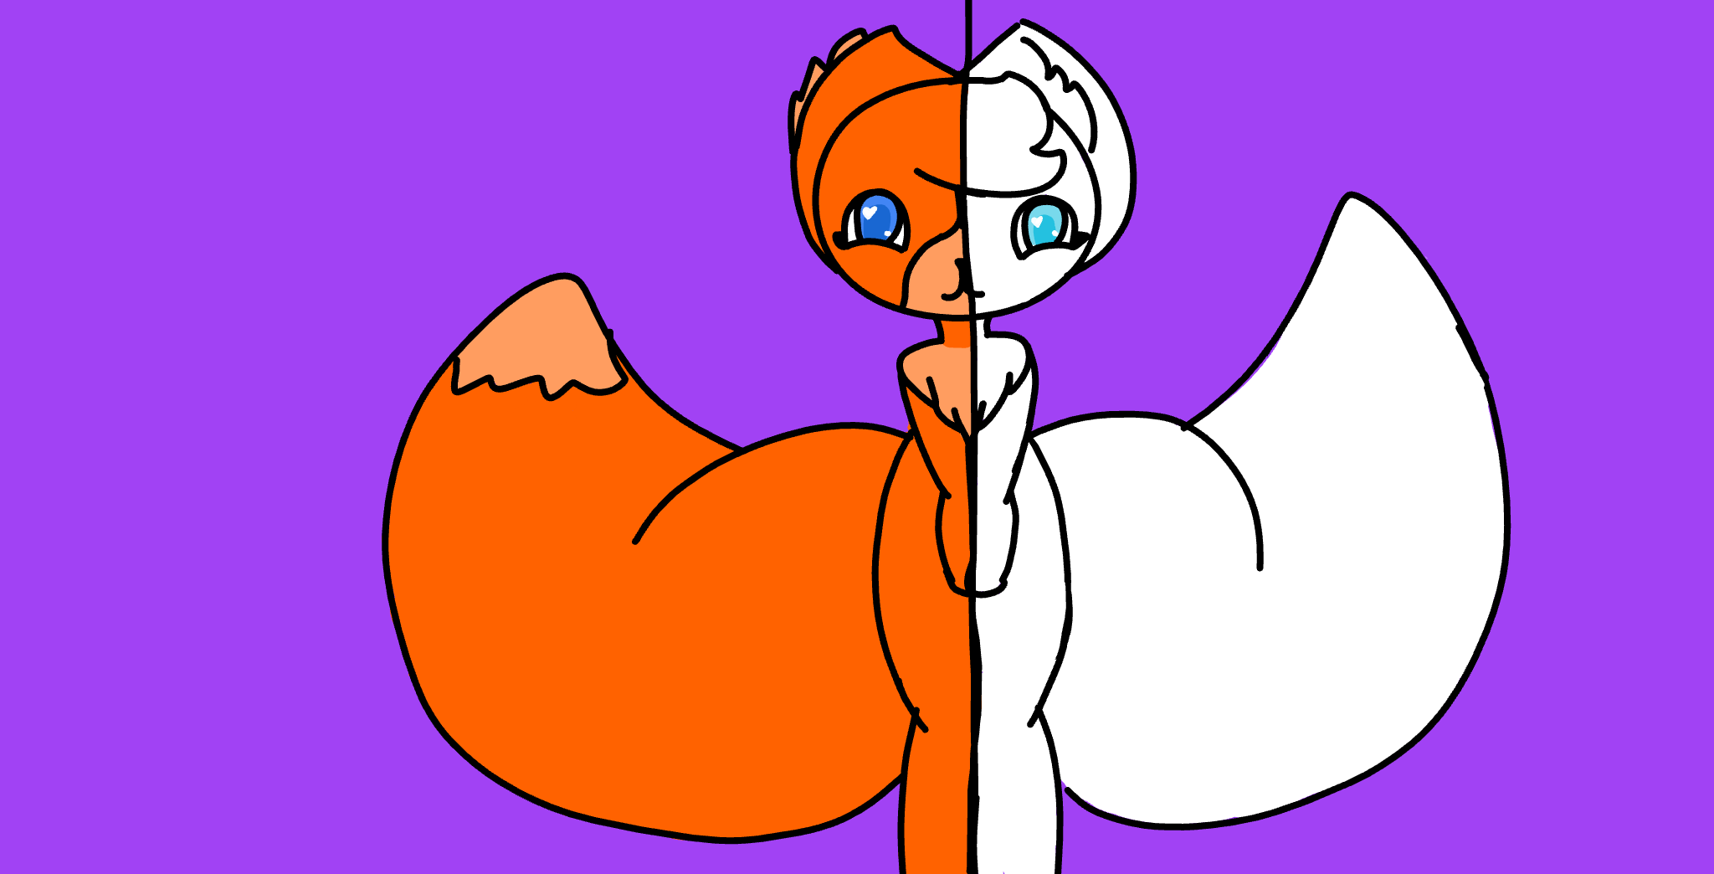
By:Brooke burkholder
west middle school

