A Grateful Heart
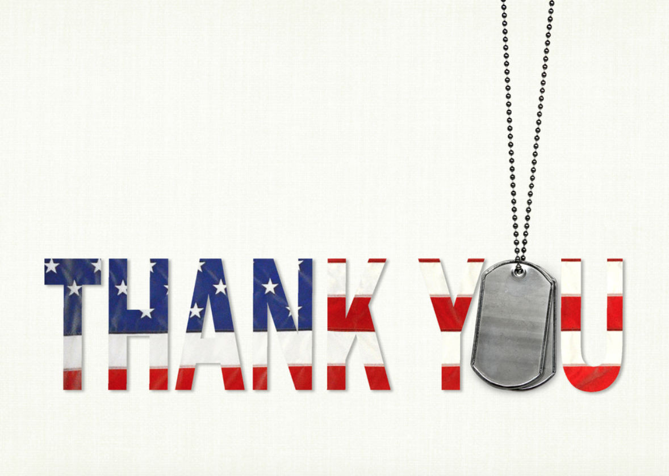
They stood up
They fought for our country
They fought on sacred ground
They helped conquer what
is now our own

They patched up the pieces
They made things right
They stood up to the fight
They took a chance that
nobody else would

They did this for you and
me
They did this in the
power of God

They achieved
They failed
But they still got back
up

God bless Veterans
‘cause I am truly thankful
for them.

By: Haley Wright
Age 10

