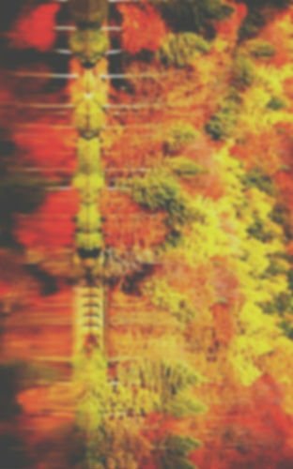
What Am I Thankful For?
Written by Julia Kadar 852
The crunching sounds of leaves as they pass underneath my feet
the kind smiles and “hellos” from people that I have yet to meet
the obnoxious bell that rings throughout the school day
the people who care for me at the talented Bay
Real gifts, like friendship, that don’t require cards nor bows
beautiful snowflakes that drift slowly and land onto my nose
conversations that end with three very special words
the merry songs and joyous tweets from the neighborhood’s birds
A bubble bath to relax in after an exhausting day
my faith strong enough to keep all my worries away
the ringing bells that signal the start of a new day
moments so perfect that they could take my breath away

