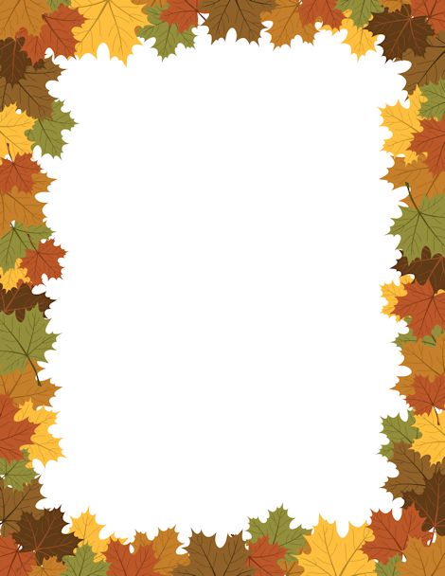

“What I am thankful for”

I am thankful for the sun, the clouds in the sky

And there is really no reason why, I like to lay

Down in the sand while I receive a tan I am

Thankful for my hand which helps me touch

And feel but to most people that is not a

Big deal

I am thankful for the trees which carry on

A lovely breeze I am thankful for emotions

Because expressing yourself is sometimes the

The only thing that could make you feel better

Sometimes

I am thankful for my brain because without it

I would not be the same I am thankful for

Food because without it I do not know

What to do, I think I should stand up and get

A snack wait, wait, wait I think I should get

Back on track I am thankful for my mom and

Dad because they love me back I am thankful

For my brother because we love each other

This is all I am thankful for

By: Paola Valentin 652

By: Paola Valentin 652

By: Paola Valentin 652

What I am Thankful For Poem