I Am Thankful For!!!!!!!!!

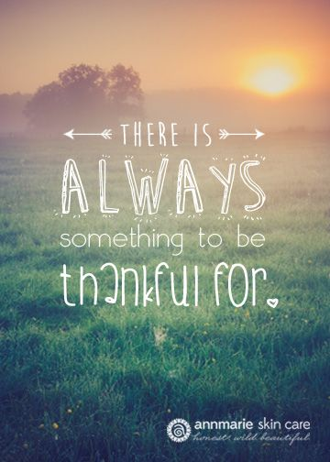

What I am Thankful For

I am thankful for my mom for helping me when I get sick and also creating me. I am thankful that she cooks, cleans and buys me stuff. I am thankful for her buying me stuff because if it wasn’t for her I would not have a phone or toys and I wouldn’t be able to write this. She is always there when I am sick. If it wasn’t for her being patient, taking me the doctor and giving me medicine, I would still be sick and never get better. My mom also helped me with my homework and she got me a tutor when she knew I needed help. If it wasn’t for her cooking I would not be eating or I would be sick of starvation. If it wasn’t for her cleaning there would be a mess in our house. If it wasn’t for my mom, I don’t know what to do.

I am thankful for my dad for helping me with homework and making me laugh when I cry. My dad buys stuff that I like and he plays games with me. Most of all he is the best dad on earth. If it wasn’t for him helping me with homework I will still be on leval 1. If it wasn’t for him making me laugh when I cry, I would never be happy. If it wasnt for him caring for me by buying me stuff that I like I wont have anything. If it wasn’t for him playing games with me I would not know what they are. If it wasn’t for my dad, I wouldn’t know what to do. My dad also protects me and from strangers and also protects people in the street, because he is an NYPD Sergeant. I admire my dad for all he does not only for me but for others.

I am thankful for my sisters and brother for being there for me when I need it, playing with me when I get bored, being with me every step of the way, and most importantly they are the best siblings in the world. If it wasn’t for them being there when I need it, I wouldn’t be as strong I am today.

I am thankful for my aunt and uncle. They are good and kind. They always make sure the see me. They do things with me, like pumpkin carving and ginger bread house building. They never forget my birthday. My aunt also helped my mom when she needed advice on how to get me help in school. She told her and helped her get me tested for the IEP I have now in school, so that I can do better in school.

I am thankful for my teachers. If it wasn’t for them, I would not be in the 5th grade. They helped me a lot with my work in school. They realized that I had a problem with learning and they did their part to get me the help that I needed. My teachers that I have now, in the 5th grade, help me everyday with my work. They are patient and kind. They tell my parents how hard I work in school and they tell them how they can help me at home with my homework.

I am thankful for my life and everything about it. I am thankful for everyone who is in my life that has helped me and continues to help me. I know that my life could be so different or I could have a bad life, so I appreciate everything that I have and everyone that I have in my life, that makes my life good.